**SEO Basics You Cannot Afford To Miss**

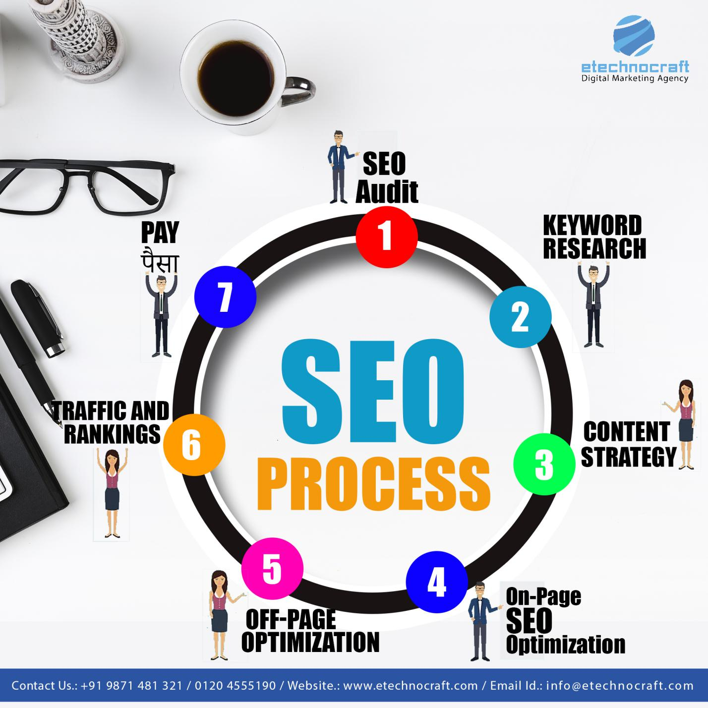

What is SEO? Is it some type of magic? To the marketing experts, Search Engine Optimization students or the people that are new to this market, SEO could certainly attract and also amaze them as magic. But, the seasoned specialists only understand, how much efforts are required to gain the fruit, in regards to increased web traffic, profits and website position. For this reason, it is said that just a little, but effective understanding of Search Engine Optimization can assist the marketing professionals, Search Engine Optimization pupils or newbie’s to grow rapidly.

**Productive-Seo-Basics-To-Win-Ranking.**

Typically to forecast the future market fads, brainstorm for an advertising campaign as well as develop likable web content, the professionals do several effective methods to sail through.

However, as a newbie or a marketing expert, you cannot excel whatsoever such techniques. Hence, one has to maintain track with the complying with basics that will aid you to prosper for sure:

1. **Outreach**.

Outreach is among the most important parts of SEO. Search Engine Optimization experts are usually known for cold emailing abilities. Their e-mails are very influential. For this reason, they do well in attracting customers throughout the world. To grab such outcomes, you can also try cold e-mails. Yet, remember to be concise.

Typically, the mails that bring in clients are:

■ Attention-getting-- writing appealing headlines is a need to for convincing mails.

■ Value-oriented-- such mails must be providing some value to the client. Before you ask something in return, you need to give some worth to the receiver.

■ It must be effectively customized according to the customer.

One more sort of email or design templates that function, are:

■ Conversational-- conversational emails usually do not look like spammy emails. It must have an informal tone.

■ Easy to review-- efficient mails are easy to check out, as they are short in length.

■ Concentrate on the main point-- such mails concentrate on the major reason or the primary topic of sending out the mail.

Such outreach practices are generally useful at the time of pitching an item, closing an offer and so on

1. **Google Updates.**

Lining up with the Google updates is essential to make it through in the market. A sudden change in the formula can completely affect your SEO strategy and positions. Therefore, to Search Engine Optimization, Google updates are like loved ones who cannot stand, being ignored.

For this reason, being a marketing expert or a rookie, one must know the upcoming Google updates, to intend the future methods appropriately. A straightforward rule that most of the **[SEO Services](http://www.etechnocraft.com/search-engine-optimization/)** follow is to comply with Google.

Which methods will work in the future and also which will be not? The solution to this concern will be clear if you follow Google appropriately. With this, forecasting the market movements will be a simple task for you.

1. **Search Phrase Information.**

Key phrase information is stated to be the entrance for recognizing the purchaser's trip. Often it is seen that the marketers spend a huge amount of time speaking with the purchasers, countless dollars in conducting the studies as well as collecting the demographic information.

Thus, drawing up the buyer's trip becomes a difficult job for online marketers. Better, the majority of the small companies do not have adequate sources to invest time and money into something complex such as this. So, exists no chance bent on determining the purchaser's trip?

Yes, there is. Through keyword data, mapping the trip can be as smooth as a cake stroll. To comprehend this, it is, first of all, essential to know the three stages in the buyer's trip that are:

■ Awareness.

■ Factor to consider.

■ Choice.

The keyword data can help you obtain an in-depth understanding right into your prospective clients. You will certainly have the ability to identify, what they think, throughout each stage of the customer's trip.

So, currently, when you learn about the keyword data, you simply need to comply with a basic 3-step treatment to map the journey--.

■ Plan out a listing of search phrases.

■ Currently, separate each search phrase right into different categories: Awareness, Factor To Consider or Choice.

■ Filter the keywords with business intent and also low traffic from each classification. The continuing to be keywords would be one of the most effective keywords.

1. **Material Advertising.**

Reports suggest that anything good for SEO is also rewarding for content marketing. As an example, as rate, trustworthiness and interaction work wonders in Search Engine Optimization; similarly, they are useful for web content advertising and marketing.

Discussing the SEO specialists, they usually create longer content, while maintaining their interesting and also understandable quotient. Hence, if you likewise develop a long material with high-quality photos in it, the engagement on your post plus the position will certainly deserve seeing. Additionally, social shares increase, if your web content has top quality images.

Website speed is likewise a major factor that a marketing expert must focus on. The conversion rate, positions and also social shares would certainly enhance if you pay correct attention to speed and also involvement.

1. **Particular Long Tail Keyword Phrases.**

Lengthy tail keywords are very chosen by the SEO experts, as traffic attracted by them is very targeted. You will certainly not obtain lots of searches in a month, but the web traffic created would be qualitative.

Such search phrases define what the customer desires. Therefore, you are familiar with the customer and also his needs or wishes. Simply put, utilizing long-tail search phrases can be worthwhile for you, to catch the prospective clients. Likewise, keep in mind that you create search phrases in a manner that pleases the needs of the consumers, as an example-- 'buy economy size bed online'.

**Final thought.**

It would not be wrong to say that whatever lessons are picked up from SEO, can be made practically applicable throughout different marketing areas. Determining the desires or requirements of the clients, creating originalities for an advertising and marketing project or marketing products to the customers; all can be easily fixed with the help of SEO. As a marketer or a beginner, understanding and also using the above-stated Search Engine Optimization fundamentals holds significant relevance. With such essentials in mind, you will certainly be able to anticipate future advertising and marketing fads, focus on involvement, readability and also rate, understand the consumer's wishes and create ingenious item ideas.

**eTechnoCraft** is a well-known company that can help you to get the revenue for your website by doing the guest post service for your website. Our expert team is creating a path for your successes which can help you to get the top result.**For More Details Contact Us :(+91) 9871481321 & Email.ID :** [eteknocrafts@gmail.com](mailto:eteknocrafts@gmail.com)

**Author by:**

This blog is done by sofia era, who is writing content from the last 2 years for digital marketing to get the new updates for readers. My hobbies are traveling and searching new for users to updates them daily.